Timetable Generator

**Team Name**

***CREW CODE***

|  |  |  |  |
| --- | --- | --- | --- |
|  | |  | |
| **Abstract**  The objective of signature matching techniques is to compute the similarity between a given signature and a signature model or reference signature set. This Application helps mathematically evaluate similarity of two signatures. Simply capture or upload the picture of both signatures to be compared. Both the images will be displayed on the screen that are being compared. The popup will show the percentage match of the signatures. The signatures are compared using structural_similarity in skimage.metrics package. | | |  |
|  | |  | |
| **Domains where our solution can be implemented**   * Authentication | | |  |
|  | |  | |
| **Our solution helping the selected domains**  As there is so much forgery happening in signature these days, this application helps by comparing the two signatures and giving accuracy percentage. | | |  |
|  | |  | |
| **Our engineering solution**  We use Python, OpenCV, Scipy and Scikit-image for optimization, segmentation, geometric transformations and image processing. | | |  |
|  | |  | |
| **Team’s vision**  Our main goal is to provide an application which provides accurate percentage by comparing two signatures. | | |  |
|  | |  | |
|  | Signature of the guide: | |  |

**Department: Computer Science and Engineering**

Name: Srilekha Devineedi RollNo:19131A05M7

Mail:1[9131a05m7@gvpce.ac.in](mailto:9131a05m7@gvpce.ac.in) Mobile:8074416741

Name: Usha Lalam RollNo:19131A05P0

Mail: [19131a05p0@gvpce.ac.in](mailto:19131a05p0@gvpce.ac.in)

Mobile: 6305116692

Name: Surya Vamsi Krishna

Chikkala

RollNo:19131A05N2

Mail: [19131a05n2@gvpce.ac.in](mailto:19131a05n2@gvpce.ac.in)

Mobile:8328014462

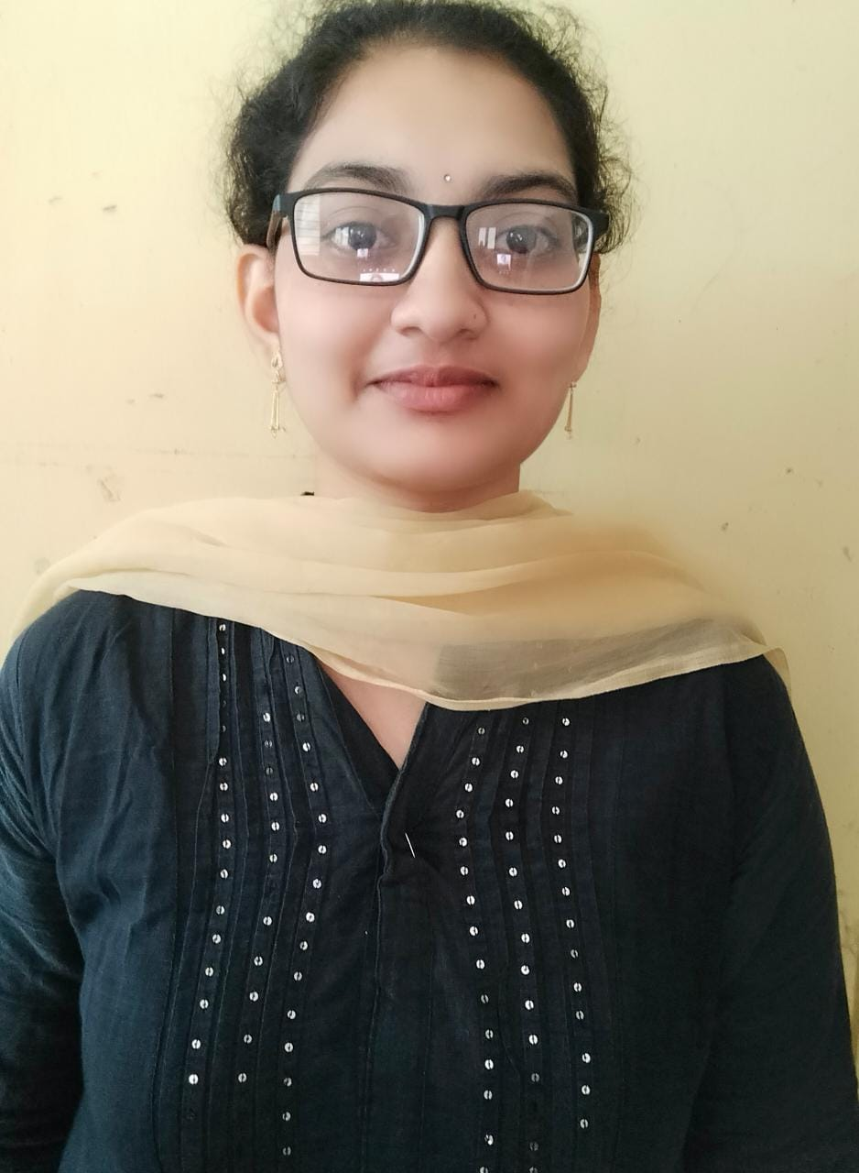



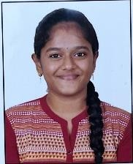

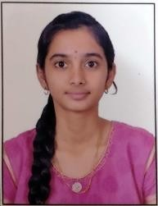

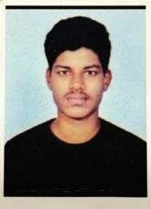

Name: Chitneedi Sridevi

RollNo:19131A0545

Mail: [19131a0545@gvpce.ac.in](mailto:19131a0545@gvpce.ac.in) Mobile: 9347898648

**PROJECT GUIDE**

Name: Dr. N.V.S

Laxmshipathi Raju  
M.Tech.,Ph.D

Associate Professor

Mail: [suribabu205@gvpce.ac.in](mailto:suribabu205@gvpce.ac.in) Mobile: 9959460471

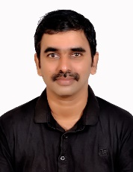

Project Last mile experience| GVP College of Engineering, Centre for Innovation